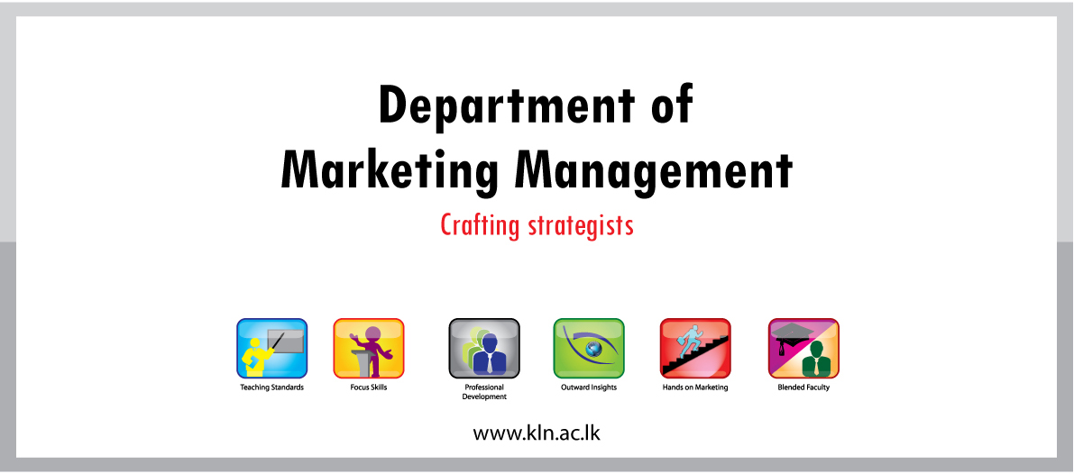
Application for "Best Achiever" Medal Sponsored by Airtel

1. Student No :
2. Name:
3. 0 FMA
3.1 Position held at FMA (President/Secretary/Treasurer/ Director / Sub Director/member/etc)

3.2 Duration :

3.3 Activities done during the working period:

4. Positions/memberships held by you at the other associations and societies of the University:

5. Professional Qualifications/Memberships:

6. Participation in field surveys (mention whether you have participated in field surveys, the year, subject and what you have studied under the survey)

7. Sports Achievements (Memberships in sports societies, Awards received in district & National level, etc…)

